* Canada has a specific shape and area and position which don't change no matter what.
* You can't encode an arbitrary new attribute with shape or area or position, they are taken already (in traditional maps)

# **Choropleth Maps**

So encoding for the position, we were using that given geometry of those area mark boundaries and then we are color coding [sequential segmented (from min to max) ]  
that attribute.

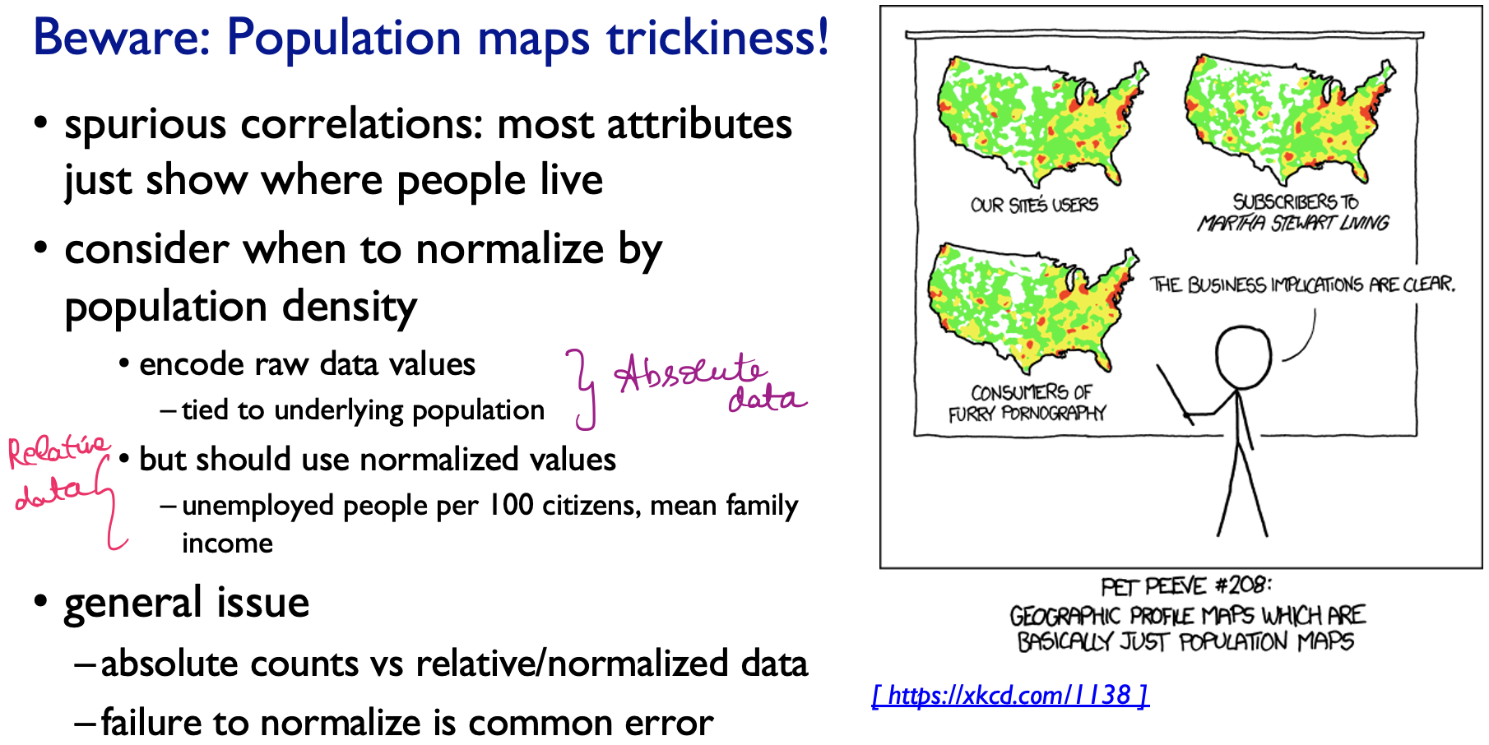

Raw data value 🡪 typically where people live.   
These values are all not be normalized (Absolute data).  
Unemployed people per 100 citizens 🡪 Relative data  
We should very well know what are all the variables must be used as absolute and relative.

## **Where to use ?**

Visual salience of that interlocking area mark depends upon the size of the region, and that might not all match up with the attribute value which is the true importance of what we are tyring to encode.

Because of this, large regions appear to be much smaller 🡪 This is not true, but we will get only this perception.

## **Pros and Cons**

# **Symbol Maps**

Point marks for state population Cuter thing of triangles depicting the Christmas trees

The issue is that they can over-lap the boundaries.

We can show multiple attributes concept (like pie-charts, histograms) within a spatial region

## **Pros and Cons**

Problem between region size versus salience of data 🡪 solved.   
Since symbol goes according to the attribute value and not according to the region size.

# **Contiguous Cartograms**

Going to have a uniform size shape for each of these geographic regions.  
There is no approximate and relative spatial positions.

## **Grid Cartogram**

# **Dot Density Maps**

## **Pros and Cons**

# **Topographic Map**

Intersection of Spatial Fields and geographic maps

Instead of associating (in thematic maps) with table, we are now associating with scalar special field.

Iso line / Iso contour is a line of equal value for that scalar attribute.

Too much of contour lines 🡪 steep slope

<https://www.tableau.com/data-insights/reference-library/visual-analytics/geospatial/symbol-maps>

<https://en.wikipedia.org/wiki/Choropleth_map#:~:text=A%20choropleth%20map%20(from%20Greek,density%20or%20per%2Dcapita%20income>.

<https://www.axismaps.com/guide/dot-density>